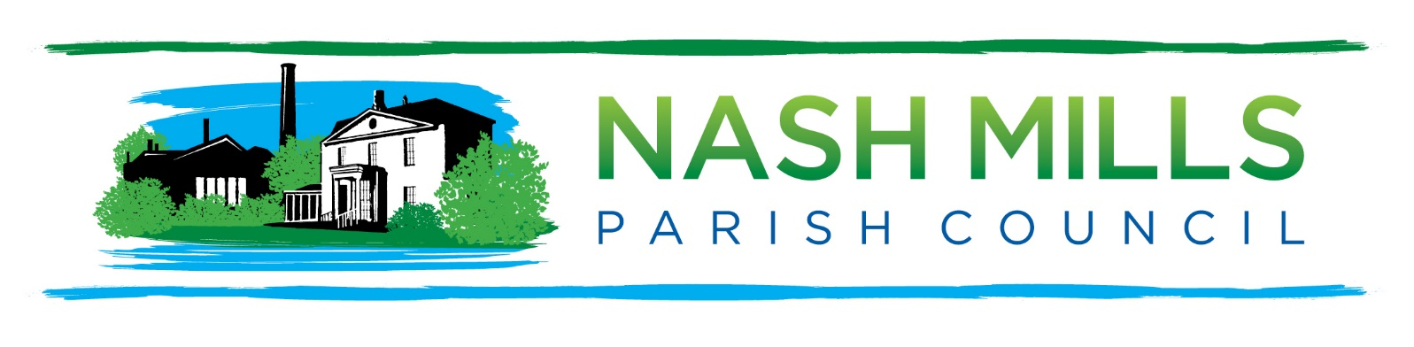Dear Residents
You are cordially invited by
the Chairman of Nash Mills Parish Council
to join us for the
Nash Mills Parish Council
Annual Parish Meeting (APM)
Monday 12th April 2021 7.30pm
Via Zoom
Please find the link on our website
Due to current coronavirus restrictions this meeting will follow a much shorter format than usual and we will be holding a parish engagement session later in the year once restrictions are lifted.
This is a meeting of the electorate and not a meeting of the Parish Council therefore standard parish business will be conducted at the 8pm meeting on the same evening.

L Bayley
Ms L Bayley
Chairman
Nash Mills Parish Council
PO Box 1602 Hemel Hempstead Herts HP1 9STE: clerk@nashmillsparishcouncil.gov.uk
please note that as this is a meeting of the electorate our standing orders will be suspended for this meeting.

Please note that due to the current Covid-19 situation, the Parish Council will meet virtually via Zoom (https://zoom.us/)

as permitted in The Local Authorities and Police and Crime Panels (Coronavirus) (Flexibility of Local Authority and Police Crime Panel Meetings) (England and Wales) Regulations 2020 (“The 2020 Regulations”)

AGENDA

- Welcome and Introduction.
- Public Participation (please pre-register with the Clerk by Thursday 8th April 2021)
- Minutes of Last Meeting.
- Annual Reports (circulated in advance)
- Date of Next APM.

