The following expenditures were resolved within agenda item 22/186/FPC Celebrations Working Group on 13th February
- NMPC authorises the purchase of a plaque for the new bench at The Denes (clerk to evidence ‘best value with 3 quotes’
- That NMPC provide photo cut out boards (subject to permissions being obtained)
- That council investigate decals in the shop windows and jubilee flags around the planters.
- That council approve the sum of £300 plus £100 contingency from earmarked reserves ‘Community Support’ to purchase these items.

Here are the details of the quotations received for review and selection:

Bench plaque

In the style of the Queen’s Green Canopy plaque.
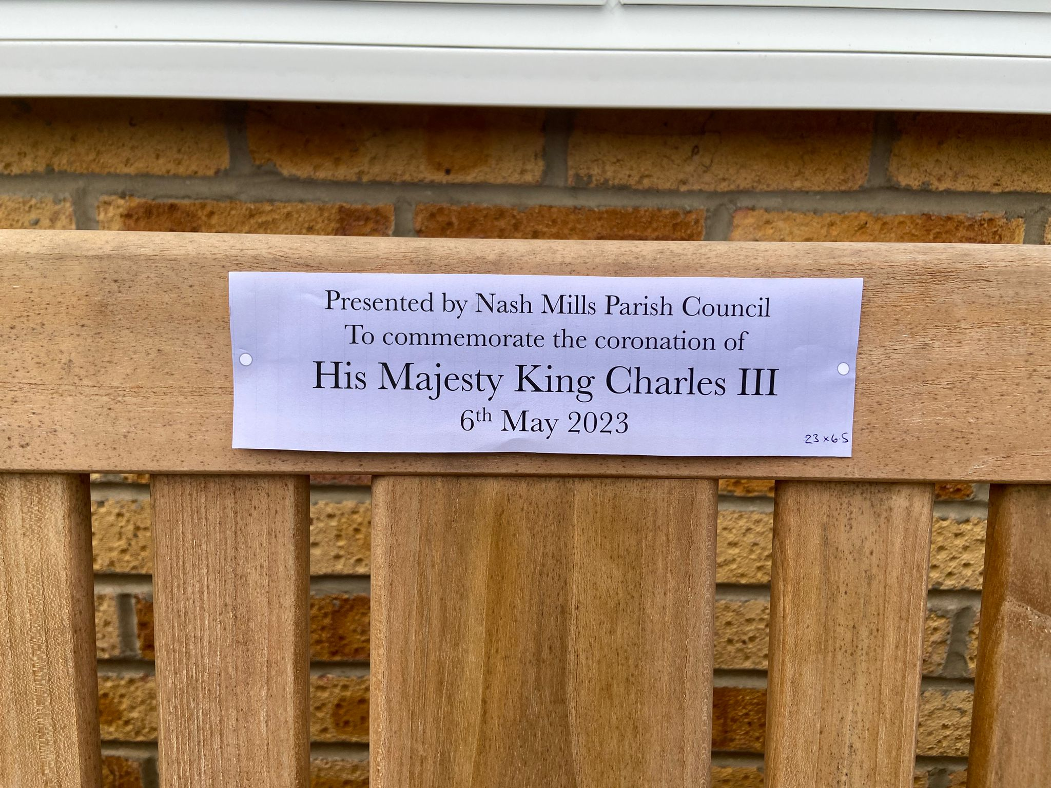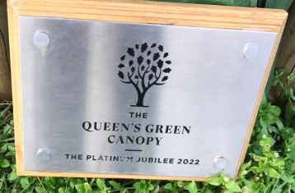

Quotation 1: Stainless steel plaque with black engraved letters 230mm x 65mm with four holes: £70 plus VAT

Quotation 2: Stainless steel plaque with black engraved letters 230mm x 65mm with four holes: £100 plus VAT

Quotation 3: Stainless steel plaque with black engraved letters 225mm x 65mm with four holes: £59.35 plus VAT

Quotation 4: pending response

FONT TO BE SELECTED

Note: “His Majesty King Charles III” to be larger font and bold.

Arial

Goudy
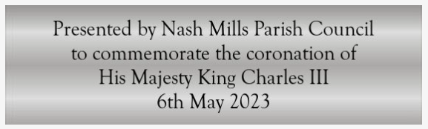

Verdana

Gills Sans

Times Roman

Photo cut-out board

The board will be attached to a structure 85cm high and 70cm wide
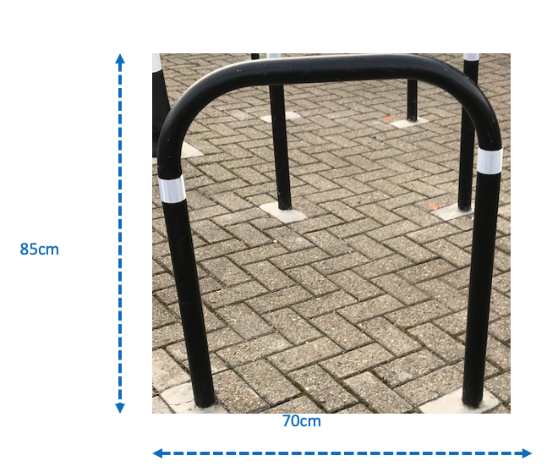

The core design requires minimum 1400mm high and 1000mm wide to accommodate the content.
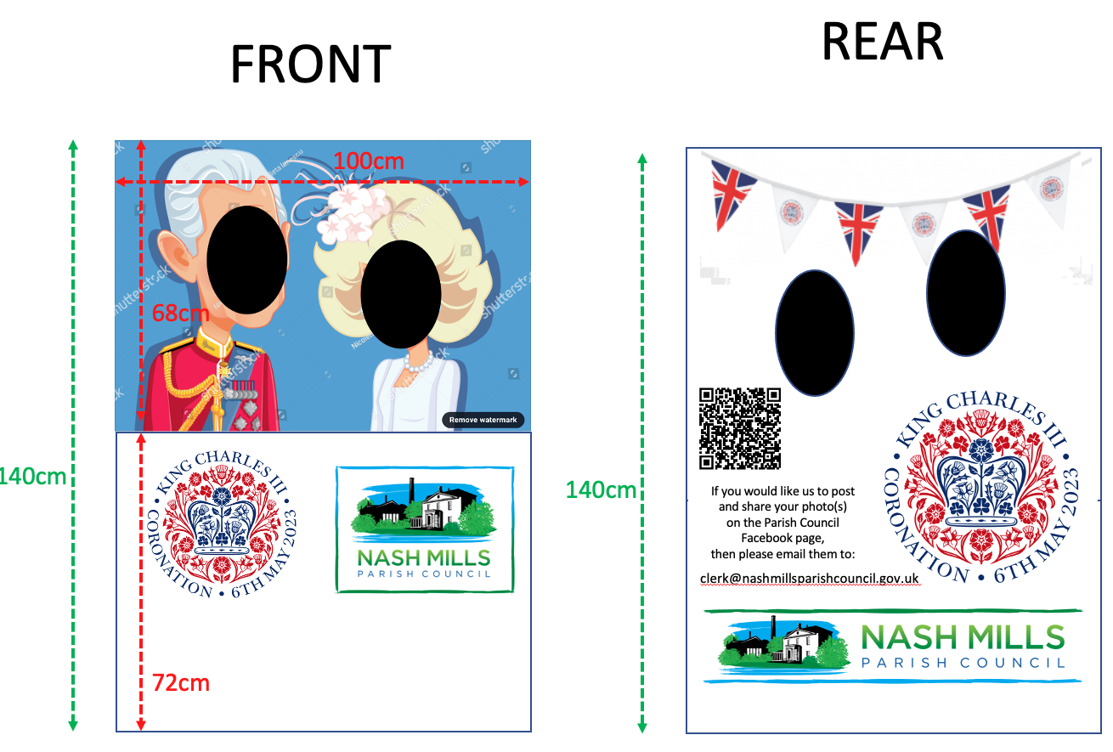

- Base Correx board is 4mm, but 5mm or 6mm would provide extra strength.
- A full sheet of Correx measures 2440mm x 1220mm and would allow lamp post signs to be printed in place of decals previously suggested.
- The board will be double-sided.

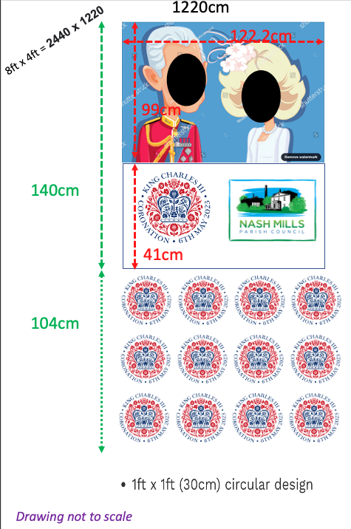

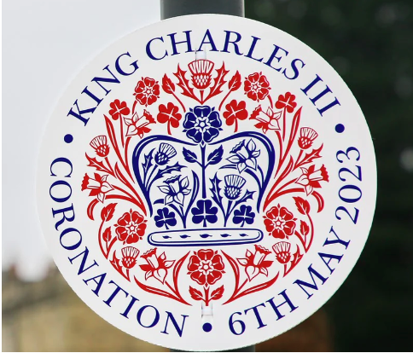
Lamp post sign (example cost £39.99 plus VAT for 10 units)

Photo Board Quotes
(including lamp post signs if 2440mm x 1220mm selected)

- : £89.25 plus VAT £170.79 plus VAT
5mm board 1400mm x 1000mm 5mm board 2440mm x 1220mm

- : 74.91 plus VAT
4mm board 1400mm x 1000mm

: £86.11 plus VAT £161.94 plus VAT
6mm board 1400mm x 1000mm 6mm board 2440mm x 1220mm

- : £80.20 plus VAT
4mm board 1400mm x 1000mm

: £101.10 plus VAT
6mm board 1400mm x 1000mm

- : £80.00 plus VAT
4mm board 1400mm x 1000mm

: £94.00 plus VAT £168.72 plus VAT
6mm board 1400mm x 1000mm 6mm board 2440mm x 1220mm

- : £93.45 plus VAT
6mm board 2440mm x 1220mm

- : £95.87 plus VAT
4mm board 2440mm x 1220mm

£109.45 plus VAT
6mm board 2440mm x 1220mm

