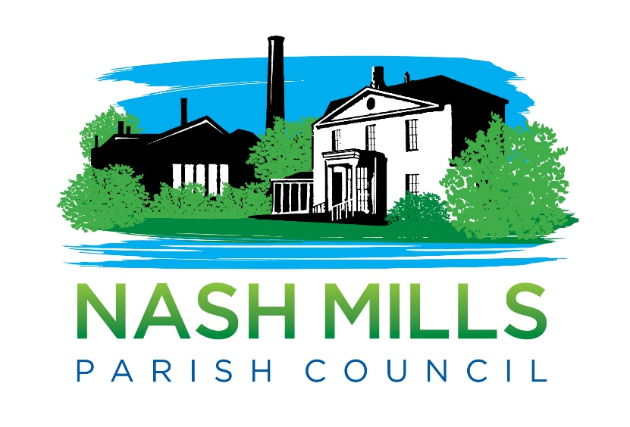

Complaints Policy v5
Adopted | February 2022
Agenda Reference | 21/035/FPC
Review Date | February 2023

1. Nash Mills Parish Council (NMPC) is committed to providing a quality service for the benefit of the people who live or work in its area or are visitors to the locality. If you are dissatisfied with the standard of service you have received from this council or are unhappy about an action or lack of action by this council, this Complaints Procedure sets out how you may complain to the council and how we shall try to resolve your complaint.

2. This Complaints Procedure applies to complaints about council administration and procedures and may include complaints about how council employees have dealt with your concerns.
3. This Complaints Procedure does not apply to:
3.1. complaints by one council employee against another council employee, or between
a council employee and the council as employer. These matters are dealt with under the council’s disciplinary and grievance procedures.
3.2. complaints against councillors. Complaints against councillors are covered by the
Code of Conduct for Members adopted by the Council on April 2022 (this is the Dacorum Borough Council version.) and, if a complaint against a councillor is received by the council, it will be referred to the Standards Committee of Dacorum Borough Council. Further information on the process of dealing with complaints against councillors may be obtained from the Monitoring Officer of Dacorum Borough Council.

4. The appropriate time for influencing Council decision-making is by raising your concerns before the Council debates and votes on a matter. You may do this by writing to the Council in advance of the meeting at which the item is to be discussed. There may also be the opportunity to raise your concerns in the public participation section of Council meetings. If you are unhappy with a Council decision, you may raise your concerns with the Council, but Standing Orders prevent the Council from re-opening issues for six months from the date of the decision, unless there are exceptional grounds to consider this necessary and the special process set out in the Standing Orders is followed.

5. You may make your complaint about the council’s procedures or administration to the Clerk. You may do this in person, by phone, or by writing to or emailing the Clerk. The addresses and numbers are set out below.

6. Wherever possible, the Clerk will try to resolve your complaint immediately. If this is not possible, the Clerk will normally try to acknowledge your complaint within five working days.

7. If you do not wish to report your complaint to the Clerk, you may make your complaint directly to the Chairman of the Council who will report your complaint to the Council.

8. The Clerk or the Council will investigate each complaint, obtaining further information as necessary from you and/or from staff or members of the Council.

9. The Clerk or the Chairman of the Council will notify you within 20 working days of the outcome of your complaint and of what action (if any) the Council proposes to take as a result of your complaint. (In exceptional cases the twenty working days timescale may have to be extended. If it is, you will be kept informed.)

10. If you are dissatisfied with the response to your complaint, you may ask for your complaint to be referred to the full Council (as appropriate) and usually within eight weeks) you will be notified in writing of the outcome of the review of your original complaint.

Clerk Contact Details:
PO Box 1602
Hemel Hempstead
Herts
HP1 9ST
07493 519458
clerk@nashmillsparishcouncil.gov.uk

Chairman Contact details: NB please mark for addressee only otherwise it will be opened by the clerk.
Cllr Lisa Bayley
C/O PO Box 1602
Hemel Hempstead
Herts
HP1 9ST
lisabayleyparish@btinternet.com

