Clerk Report – Deposit Accounts April 2024

Council Actions Required
- That council considers the clerks recommendations to maximise the council interest on deposits without any risk and then determines any further actions arising for investigation.
Council should note that there is strict regulation of how/where local authorities can invest their funds Guidance is provided by government and can be found in this document Guidance_on_local_government_investments.pdf (publishing.service.gov.uk)

Clerk Recommendation
Please note that these balances and interest rates are applicable at the time of writing this report.
Existing Account | Balance | Current Interest Rate | Suggested move
NatWest Business Reserve | 61868.75 | 1.45% (1.46 AER)  Variable Instant access, daily interest | Use the NatWest notice accounts  NW-Liquidity-Manager-notice-account-info-sheet.pdf  Move £30000 to NatWest 95 Day Notice (liquidity manager) account  Interest rate 4.17% (4.25% AER) variable  NW-Liquidity-Manager-Notice-Account-Info-95.pdf  Care: no withdrawals are permitted without notice.  Risk should be assessed and added to financial risk assessment.  Move £20000 to NatWest 35 Day Notice account  3.2% (3.25% AER)  NW-Liquidity-Manager-Notice-Account-Info-35.pdf
NatWest Current AC | 9642.28 | No int | Move £9000 to NatWest Business Reserve (instant access) 1.45% (1.46% AER)
Lloyds Current Account | 786.44  (this will be inflated by the precept April 2024 £40k) | No int | Leave as is for usual planned council expenditure
Lloyds 32-day notice account | 22700.65 | 2.6%  Daily int | Move £10000 across to the Lloyds fixed term deposit account. (council to choose term from below)  Interest rate fixed for the duration  Once deposited no additions permitted.  No withdrawals permitted  Fixed Term Deposit | Business | Lloyds Bank
Fixed Term Deposit | 6 months | 3.50% | 3.53% AER
Fixed Term Deposit | 9 months | 3.55% | 3.57% AER
Fixed Term Deposit | 12 months | 3.60% | 3.60% AER
Remaining on instant access | Lloyds CA | £40000 | This should cover all budgeted expenditure for the year.
 | NatWest CA | £642 (topped up by VAT reclaims quarterly)
 | NatWest BR | £11000

Background
NMPC currently hold £94998 (excluding year end interest) in all accounts. The breakdown is listed above. Previously council determined that they wished the clerk to ensure that all funds are held under the financial services compensation scheme (FSCS) and therefore balances have been split between two high street banks. There are alternative, sector specific investment banks such as CCLA, however even though these are deemed very low risk council previously determined that they did not wish to investigate any supplier that had any element of risk or who worked outside of the FSCS.

Considerations
Public Sector accounts are hard to open now with some high street banks refusing new applications. NMPC could stay with their existing providers, enabling them to remain with current signatories and internal control procedures and move the funds across to alternative accounts to enable them to obtain a higher rate of interest.
As RFO I would recommend that the main precept is left on instant access as this will be used for our annual expenditure but that the remaining funds held as reserves are split across the following type of accounts to enable it to be spread across the best interest rates whilst still allowing for transfers (with notice) should council wish to make any additional, unexpected expenditure.

Future Actions for a later date/budget consideration
Once council have determined the options and made a decision the financial management risk assessment will need to be updated to take into account, the risk of having any products on longer term notice periods. The investment policy will also need updating.

Suggested Alternatives
Council could choose to request that the clerk investigates the CCLA products for council consideration. (the public sector deposit fund is used by many local councils, has an interest rate currently in excess of 5% but is not covered by the FSCS).
The Public Sector Deposit Fund | CCLA
Local authorities | CCLA

Bank Reconciliation (waiting for year-end interest to be received) 28th March 2024
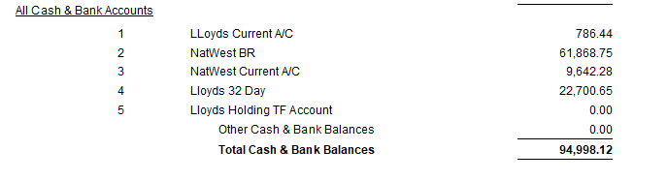
Reserves 28TH March 2024
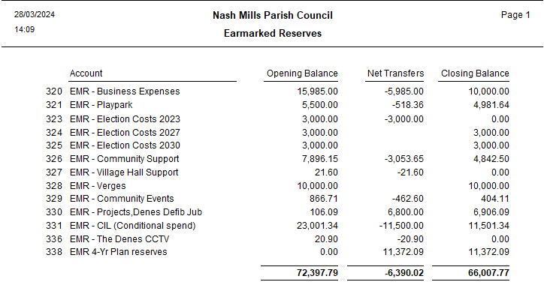

Advice notes from SLCC GN65
ADVICE NOTE: Investments (England only)
1. This Advice Note applies only to parish and town councils in England.
2. Councils have the power to invest for any purpose relevant to their functions under any enactment, or for the purposes of the prudent management of their financial affairs (section 12 of the Local Government Act 2003, the ‘2003 Act’).
3. The Government has issued guidance on local government investments under section 15 of the 2003 Act (‘the Guidance’) and this has statutory force. The latest edition, which applies for accounting periods starting on or after 1 April 2018, can be found at Guidance_on_local_government_investments.pdf (publishing.service.gov.uk)
Clerks/RFOs should download and read both the Guidance and the ‘informal commentary’ annexed to it.
4. The Guidance is mandatory where investments of a parish or town council exceed or are expected to exceed £100,000 at any point in a financial year (see paragraph 14 of the Guidance on page 2). Note that this is a lower limit than for the previous edition (see paragraph 11 of the non-statutory commentary on page 10). Parish or town councils where investments are expected to exceed £10,000 are encouraged to adopt the principles in the Guidance.
5. ‘Investment’ in the Guidance is very widely defined (see paragraph 4 of the Guidance on page 1) and includes non-financial investments such as property investments. It follows that where councils own or lease property they need to be clear as to whether the property is held for the purposes of enabling the council to perform its functions or as an investment. This can be a difficult decision where a council expects or hopes to make a profit from property ownership.
6. Where the Guidance is mandatory, or where a council has adopted the principles in the Guidance, the council must, at a Full Council meeting, adopt an investment strategy for each financial year (see paragraphs 15-19 of the Guidance on pages 2-3 and paragraphs 12-17 of the non-statutory commentary on pages 10-11).
7. The key paragraphs in the Guidance are paragraphs 26-29 on page 4, discussing security, liquidity and yield. Yield should always be a much less important factor than security and liquidity.
8. A parish or town council has a number of powers to make loans to organisations and this is covered in paragraph 33-34 of the Guidance on page 5 and paragraph 27 of the non-statutory commentary on page 14. However as local councils do not publish a balance sheet there is no financial benefit to a local council in making a loan and it may put pressure on the borrower: it may be in everyone’s interest to make a grant instead.
9. All councils need to have regard to paragraphs 48-50 of the Guidance (on page 8) and paragraphs 38-40 of the non-statutory commentary (on page 16) on capacity, skills and culture. With more devolution of services and assets to local councils many councils may want to consider whether a higher degree of professionalism is required.

Nikki Bugden 28/3/2024

