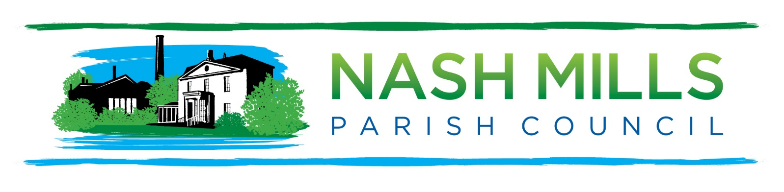
Dear Residents
You are cordially invited by
the Chairman of Nash Mills Parish Council
to join us for the
Nash Mills
Annual Parish Meeting (APM)
Monday 13th May 2023 7.30pm
Nash Mills Village Hall

This is a meeting of the electorate and not a meeting of the Parish Council therefore standard parish business will be conducted at the 7.45pm meeting on the same evening.

L Bayley
Ms L Bayley
Chairman
Nash Mills Parish Council
20th April 2024
PO Box 1602 Hemel Hempstead Herts HP1 9STE: clerk@nashmillsparishcouncil.gov.uk
Please note that as this is a meeting of the electorate our standing orders will be suspended for this meeting.

AGENDA

- Welcome and Introduction.

- Public Participation
(If you wish to participate, please pre-register with the Clerk by 9am Thursday 9th May 2024)

- Minutes of Last Meeting.

- Annual Reports (circulated in advance)

- Date of Next APM.

