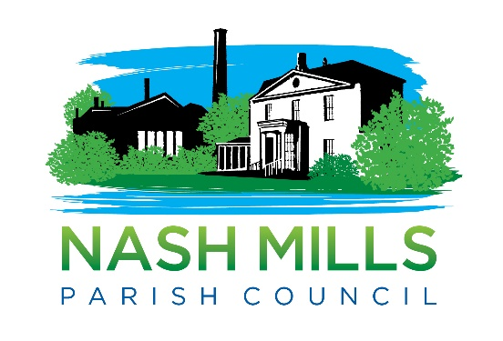

AGENDA REQUEST FORM

(FOR ITEMS OUTSIDE OF WORKING GROUP MATTERS)

PLEASE NOTE THAT AGENDA ITEMS MUST BE SUBMITTED PRIOR TO THE AGENDA CUT OFF DATE

Please note the clerk will endeavour to include your request, however the clerk will decide its suitability in line with statutory guidelines and other agenda items may take precedence.

CLLR NAME: | Alan Briggs | DATE: | 11/06/2024

AGENDA ITEMS - INSERT WORDING TO APPEAR ON THE AGENDA. REMEMBER TO MAKE IT CLEAR WHAT YOU ARE ASKING COUNCILLORS TO DECIDE. PLEASE ALSO NOTE IF YOU ARE LOOKING FOR A SPECIFIC RESOLUTION.
“To consider…” “To note…” “To review…” “To agree….”
To consider whether NMPC should implement Microsoft’s Two-Factor Authentication functionality.
There are an ever-increasing numbers of data hacks / breaches and in this context, NMPC should consider introducing this extra layer of protection.
BACKGROUND INFORMATION - INSERT AS MUCH INFORMATION AS POSSIBLE SO THAT COUNCILLORS HAVE THE DETAIL THAT THEY NEED IN ORDER TO MAKE AN INFORMED DECISION.
What is Two-Factor Authentication?
Two-factor authentication is a means in which someone is granted access to a website or an application after submitting multiple pieces of evidence, also known as factors, to an authentication program or mechanism. It’s an extra level of security for online accounts that requires you to verify that you are the owner of the accounts, and not just someone who knows the correct password.
During a data breach, a username-password combination can be easily stolen, but this additional credential can keep your data safe because to access an account, someone will need a factor that belongs specifically to you.

Microsoft have a standard application to use in conjunction with the 365 platform that NMPC uses.

BACKGROUND DOCUMENTS LIST NAMES OF ANY DOCUMENTS OR SUPPORTING INFORMATION TO BE ATTACHED. ALL DOCUMENTS MUST BE SUBMITTED WITH THE REQUEST.
https://www.microsoft.com/en-us/microsoft-365-life-hacks/privacy-and-safety/importance-of-two-factor-authentication

https://support.microsoft.com/en-gb/topic/what-is-multifactor-authentication-e5e39437-121c-be60-d123-eda06bddf661

COSTS - INSERT DETAIL OF COSTS ASSOCIATED WITH THE DECISION THAT YOU ARE ASKING THE COUNCIL TO MAKE (IF KNOWN).
None (presumed).

Benefit To Residents/Local Area
NMPC data benefits from an additional layer of security.

