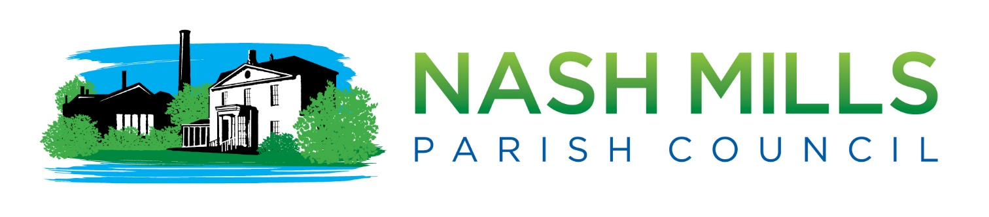

RFO Report Finance Q1 30th June 2024

Please note that the full financial figures are listed at the end of this document. These are from a third-party software programme and therefore are not able to be made accessible in this document. Please contact the clerk should you require assistance.

Summary

Nash Mills Parish Council (NMPC) is now at the end of the first quarter of the new financial year 2024/25. Precept and grants have been received.
Total balances held on accounts (less NatWest final interest payment) on 30th June 2024 £132689.38
of which £64582 is currently earmarked (see below)

Ongoing Matters/ Projects in Progress
An asset review has been undertaken and the clerk is in the process of investigating permissions. Funds will be earmarked once scope of project is known (currently approx. £4000) plus new bin and bench in playpark
There may be some expenditure incurred when the lease for the playpark is renegotiated as there are a number of improvements/repairs that the council may wish to pursue.

Other considerations for potential earmarking or allocation of funds
- Library Box
- Parish Map £5000 to be earmarked for artist and lectern style signage
- Playpark swing repairs (initial quotes circa (£1000-£1500)-outcome dependent on lease renewal decision
- Additional playpark repairs/improvements (to be determined)
- Verges phase 2

Financial Headlines

Position 30th June 2023 (income/expenditure)

 | Budget | Actual | Variance | Notes
Income | 51425 | 52418 | (993) | Precept as budgeted has been received in full.  Bank accounts have been reworked to place some funds on notice accounts to offer more interest and to spread the risk.  CIL money has been awarded (this is not in budget)  £75 compensation due from NatWest due to a complaint lodged by clerk.
Expenditure | 52477 | 14841 | 37636 | We are only one quarter into our annual expenditure

Budget heading Overspends over £100 or 15% of budget (reported as required in our Financial Regulations)
Too early in the year to report under this heading. No concerns at present.

Budget Heading Underspends over £100 or 15% of budget (reported as per our Financial Regulations)
Too early in the year to report under this heading. No concerns at present.

Invoices Income Due
None
Nikki Bugden
Clerk to the Council 4th July 2024

Attached
Earmarked Reserves
Bank reconciliation -All Accounts
Receipts and Payments details
Please note that documents from this point onwards are from third party software and are therefore not accessible. Please ask the clerk should you require additional formats.

Earmarked Reserves

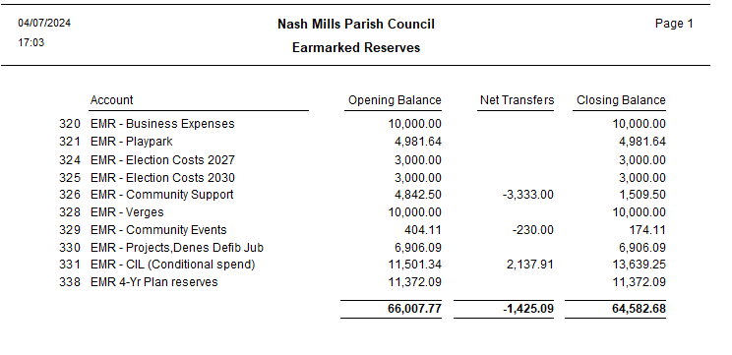

Bank reconciliation All Accounts

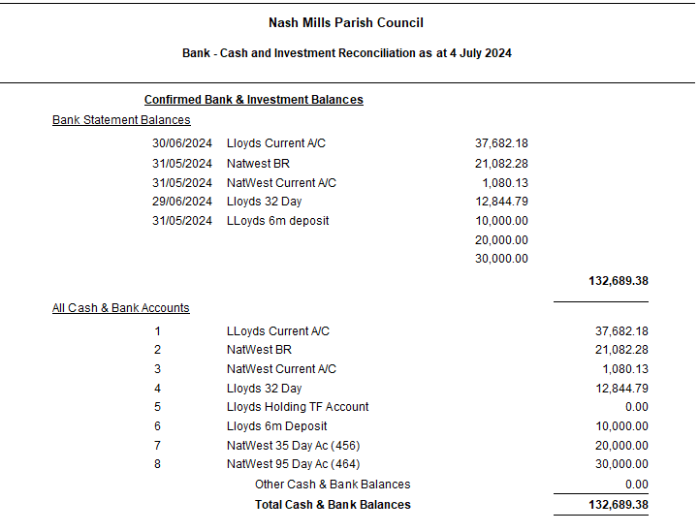

Receipts and Payments details

