# 

**Clerk Report –Speed Indicator Devices (SIDS) Insurance Costs November 2024**

## **Council Actions Required (agenda items)**

* To consider whether NMPC wish to fund the Herts County Council Insurance costs due for 2 of the SIDS
* To determine which budget heading these funds should be taken from (if approved)

## **Background**

In March 2021 NMPC funded 2 SIDs costing in total £10500. These were installed at Bunkers Lane and on Georgewood Road.

They remained HCC assets.

At the time of installation, I raised the issue of breakdown/defects and received the following email from HCC.

Email from Highways Locality Officer 11/5/2022

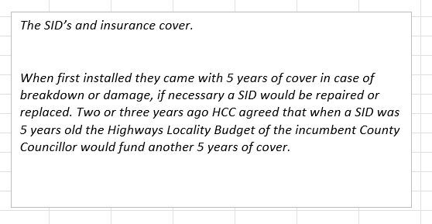

**8th October 2024 I received the following email (please note it was correctwd to 2 SIDS not 3 as one was Police Crime and Commissioners Office funded)**

*Our records show that three of the Speed Indicator Devices (SIDs) previously funded by the parish council have warranties that are due to expire in 25/26. Locations below.*

*An option is available to extend the warranty of each SID for 5 years at a cost of £1000 each. This will cover the cost of any malfunctions, breakages or damage to either the SID, solar panel or post, including complete replacement if necessary. If the option is not taken to renew the warranty the SID will be removed permanently if it breaks or is damaged.*

*Grateful if the council could consider if they wish to renew the warranties or not. If you could let us know by March 2025 at the latest.*

Since that point I have had conversations with the HCC Officer and County Cllr Maddern. Considering the email above from 2022 I still believe that these costs are not the responsibility of NMPC, however the County Councillor has confirmed that she does not have the remaining budget to cover the cost for them as was not aware of the undertaking given by HCC.

## **Considerations & Clerk Recommendations**

The clerk **recommends** that NMPC formally ask HCC and the County Councillor to honour the commitment given in March 2022 but with an NMPC CIL reserves provision that if there is absolutely no alternative the funds could be taken from CIL to prevent the loss of the SIDS and gain an additional 5 years cover.

Council should be mindful that currently HCC are saying there are no funds available. Should the SIDS fail, they will simply be removed, therefore the asset purchases of £10500 may have only benefitted the residents for 4 years. An additional 5 years costing £2000 in total may give the asset expenditure a more appropriate working life.

* Councillors will need to consider if this project is a good use of CIL funds and to appraise the benefit to the NMPC residents.
* Councillors need to appraise the benefit derived from the SIDS in their locations.
* NMPC would need to consider other potential ClL projects (existing and also on this Nov agenda)
* Cllr should note that CIL expenditure is a conditional spend with terms attached, it has an expiry date-(see table below). I am currently waiting to hear back from DBC to see if the Map Project/Bleed Kit & Library Box can be used to clear our balance that expires in 2025.

a table of CIL expenditure and expiry dates totalling £17125.04

Nikki Bugden

Clerk & RFO

1/11/2024