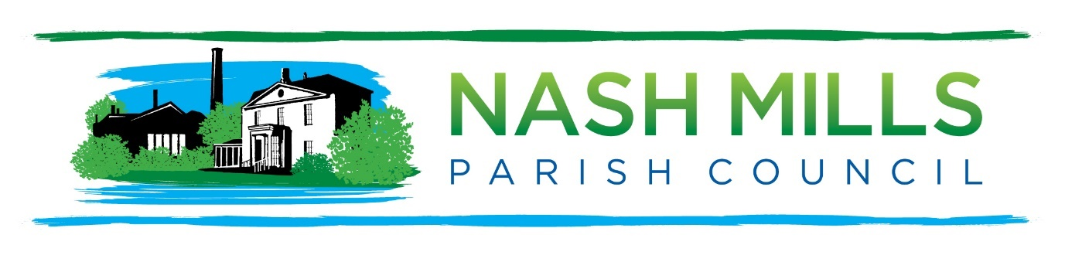
Exciting Job Opportunity: Parish Council Clerk
and Responsible Financial Officer (RFO)
Location: Nash Mills Parish Council. This is predominantly a working from home position with attendance at meetings, including some evening meetings, expected.

Salary: LC2 (NJC Scales, starting at £30,559 full-time equivalent, commensurate with experience and qualifications)
Hours: Part-time, 24 hours per week (with flexibility and the possibility of annualised hours)
Contract Type: Permanent (subject to successful probationary period)

Are you passionate about your local community? Do you have a flair for organization and a keen eye for detail? Nash Mills Parish Council is seeking a dedicated and enthusiastic Parish Council Clerk and Responsible Financial Officer (RFO) to play a key role in supporting the smooth running of our vibrant community.
This is a dynamic and rewarding position, offering a unique opportunity to contribute to local governance while enjoying a flexible working environment. If you're an organized professional with a strong financial background and a commitment to making a positive impact, we want to hear from you!
What You’ll Be Doing:
- Act as the main point of contact for the Parish Council, offering expert advice to ensure compliance with legal, procedural, and financial standards.
- Prepare agendas and minutes for Council meetings, ensuring accurate and timely documentation.
- Manage the Council’s finances: budgeting, payroll, and preparing financial reports
- Line manage the Parish Warden and oversee their day-to-day responsibilities.
- Ensure the proper administration of finances, meeting all audit and governance requirements.
- Keep Council records, policies, and other documents up to date.
- Liaise with residents, contractors, and other authorities to maintain open communication and ensure projects run efficiently.
- Play an active role in implementing Council decisions and helping push forward community-focused projects.
What We’re Looking For:
- Strong organizational skills and the ability to manage multiple tasks with attention to detail.
- Experience in financial management (including budgeting and bookkeeping), with familiarity in sector-specific software like Scribe or Rialtas an advantage.
- Excellent written and verbal communication skills.
- Proficiency in Microsoft Office (Word, Excel, Outlook, Teams) and general IT systems.
- Knowledge of local government procedures and legislation (CiLCA qualification is desirable, or a willingness to pursue it).
- A self-starter who can work independently, prioritize effectively, and meet deadlines.
What We Offer:
- A competitive salary based on your experience and qualifications.
- Flexible working arrangements, allowing for a better work-life balance.
- Generous annual leave entitlement in line with NJC scales.
- Working from home (attending periodic meetings also required). Allowances and expenses will be provided.
- Training and development opportunities to support your career progression, including assistance in obtaining the Certificate in Local Council Administration (CiLCA).
- A supportive team environment, where you can truly make a difference in your community.
Ready to Apply?
If you’re excited about the opportunity to serve the Nash Mills community and bring your expertise to this vital role, we’d love to hear from you! Please send your CV and a covering letter to Nikki Bugden at clerk@nashmillsparishcouncil.gov.uk
Application Deadline: Monday, 3rd February 2025
Interview Date: Monday, 10th February 2025
For any questions or an informal chat about the role, please contact Nikki Bugden at clerk@nashmillsparishcouncil.gov.uk
We look forward to welcoming a new member to our dedicated team – someone who shares our commitment to helping Nash Mills thrive!

