REPORT TO COUNCIL FOR FEBRUARY 2025 MEETING

**2025 - VERGES**

On the 8th of January 2025 Councilors Michele Berkeley, Alan Briggs and Nicola Cobb walked the Parish of Nash Mills to review the current state of the Verges and to determine which areas should be included within our new **2025 Verges** Report to bring back to full council for discussion.

Included within this report are photographs with a description of the issue and possible solutions for discussion.

**BARNACRES ROAD (514-518)** – Verge has been destroyed, and a resident had previously emailed in 2021 to complain. Jan Maddern and DBC were making investigations into this matter. To date nothing has been done to resolve the problem.

S*uggestion is to ask the Clerk to raise this concern again with DBC and Jan and to find out if this is on the council list of ‘Parking Solutions’ and if not, then could it be included.*

|  |  |
| --- | --- |
| *Barnacres Road - damaged verge* | *Barnacres Road - damaged verge* |

*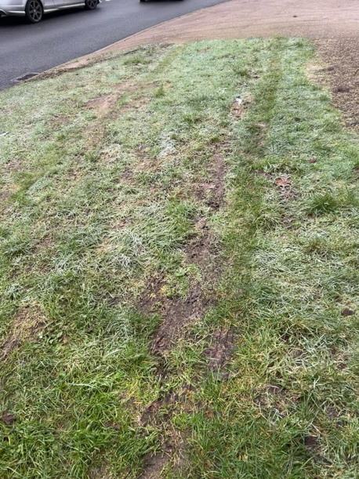***CHAMBERSBURY LANE (87-89 and 120)** – Verges are being used once again for parking.

*Suggestion is to ask the Clerk to ask DBC if additional trees could be planted in this area, as have been planted along Georgewood, as this would look good and deter parking.*

**CHAMBERSBURY LANE (Junction Market Oak near entrance to Park)** – Verges are being used once again for parking.

*Suggestion is to ask the Clerk to ask DBC if additional trees could be planted in this area as have been planted along Georgewood as this would look good and deter parking.*

|  |  |
| --- | --- |
| *Chambersbury Lane, near green space and Little Wood* | *Chambersbury Lane, near green space and Little Wood* |

**EAST GREEN** – Verges are constantly being used for parking and are destroyed. Highways carried out repairs to ‘Hole’ at this area and now residents are parking again.

*Suggestion is to ask Clerk to ask DBC if this area is on the designated ‘Parking Solutions’ list and if not, then could it be included for hardening.*

*Suggestion if it cannot be done by DBC then the alternative will be to obtain a cost and approval for works to be done and paid for by the Parish Council.*

|  |  |
| --- | --- |
| *East Green damaged verge* | *East Green damaged verge* |

*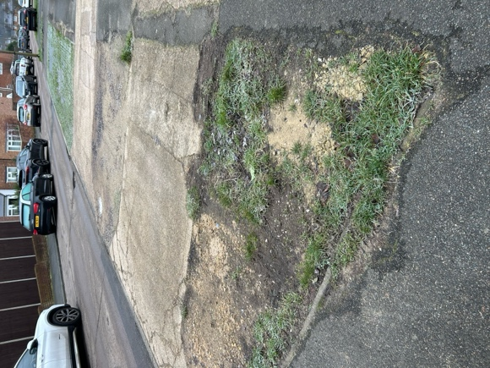***39 MEADOW ROAD** *– Small area that was not completed with grasscrete programme.*

*Suggestion is to ask the Clerk to once again ask DBC if this small area could be completed as part of their programme.*

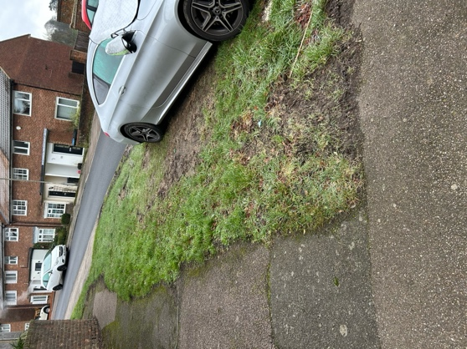

**CHAMBERSBURY LANE (opposite No. 10 Highbarns)** *– Verge is being used for parking.*

DBC had previously advised in December 2020 that Tarmac Apron would be extended to create 2 parking spaces with a dropped kerb.

S*uggestion is to ask the Clerk to ask DBC for further advice on this area to see if it is on the designated ‘Parking Solutions’ list and if these works have been approved.*

**CHAFFINCHES GREEN** – Continual problems with parking on verges which have been highlighted by a resident on numerous occasions. Jan and DBC were looking at options to resolve parking issues and a Highways Report was due to be carried out. Nothing has been seen to date to resolve the parking issue.

*Suggestion is to ask the Clerk to ask DBC if this area is on the designated ‘Parking Solutions’ list and what are their solutions for this problematic area as it has been discussed and visited many times.*

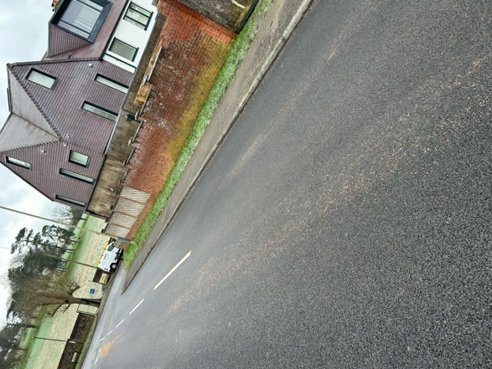**PARKING AT JUNCTION CHAMBERSBURY LANE & BUNKERS LANE -** This is an ongoing issue and Jan and DBC are monitoring this problem with possible solutions.

*Suggestion to ask Clerk to keep these roads on the list so that they can be continually reviewed.*

We understand that a new Project Manager is being recruited to deliver the new Parking Solutions Policy at DBC and we are waiting to hear who the successful candidate will be that we can work with.

Once the full list has been provided, we as a Council will be able to evaluate and make further progress.